**Calculator Assumed**

**Random Sampling and Distributions**

Time: 45 minutes

Total Marks: 45

Your Score: / 45



**Question One: [2, 2, 3, 3 = 10 marks] CA**

For each of the following samples, determine whether the sample is bias and if so, state the reason(s) for the bias.

(a) During an episode of The Biggest Loser, a weight loss show, the viewing audience were asked to SMS in either Yes or No to the following question: “Do you eat fastfood more than once a week?”

(b) A class of Year 8 students are asked to complete a compulsory survey for the following question: “Should the School reduce the lunch hour to 30 minutes?”

(c) A random sample of residents in a particular suburb were asked: “Do you prefer Hungry Jacks’ over other competitors?”

(d) Over the course of a Saturday, shoppers in the city central shopping mall were approached and asked: “Do you think the US response to the September 11 attacks was appropriate?”

**Question Two: [5 marks] CA**

At the office of Dunder/Mifflin, a company selling stationery supplies, there are the following number of employees:

1 Manager

7 Sales Representatives

2 Office Assistants

3 Accountants

13 Warehouse employees

The Manager, Michael Scott, wants the Human Resources representative to survey 5 staff on the success of their Positivity Day.

If the Human Resources representative does this proportionally, how many of each staff group should he select?

**Question Three: [3, 3 = 6 marks] CA**

Two digit random numbers have been created using an excel spreadsheet. A screen shot of these numbers is shown below.

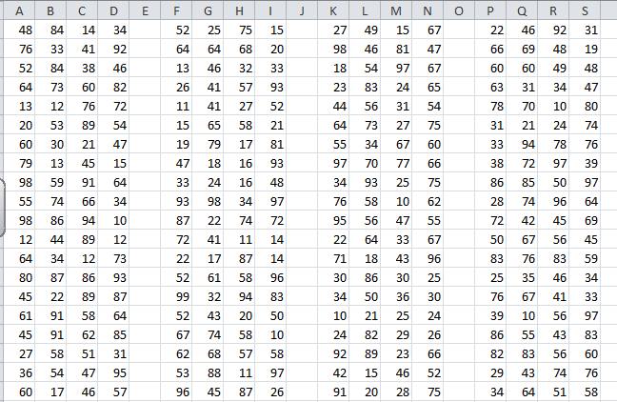

(a) Starting in column F and row 5, collect a systematic sample of size 8 of numbers between 74 and 150 inclusive.

(b) Landline phone numbers in Australia begin with an area code, followed by a 9 and then followed by 7 digits. Starting in column K and row 15, collect a sample of 10 phone numbers (ignoring the area codes).

**Question Four: [2, 2, 2, 3 = 9 marks] CA**

At a particular bus stop during morning peak hour, the waiting time for the next bus is between 0 seconds and 300 minutes.

(a) Define the random variable that would model this situation.

(b) Determine the mean and standard deviation for this distribution.

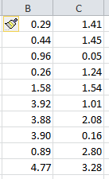During peak hour on a Monday morning, random samples of waiting times were observed for this bus stop. These times are shown below.

(c) Calculate the mean and standard deviation for the above sample.

(d) By grouping the data appropriately, draw a graph of the sample distribution on the axes below.

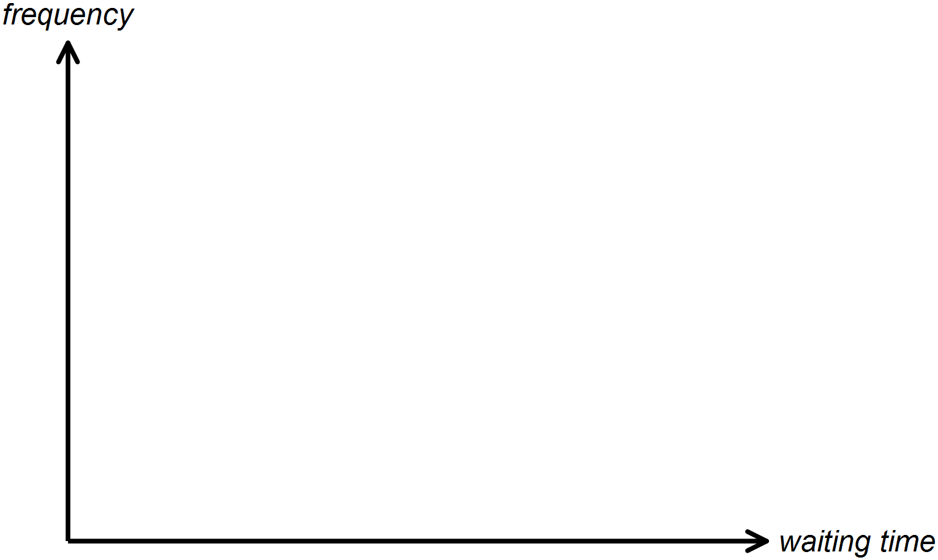

**Question Five: [2, 2, 3, 2 = 9 marks] CA**

A Bernoulli trial is such that the probability of success is 0.4.

Two random samples of 12 trials is given below:

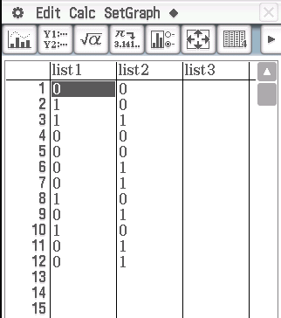

(a) Calculate the mean and standard deviation of the first sample, given in list 1.

(b) Calculate the mean and standard deviation of the second sample, given in list 2.

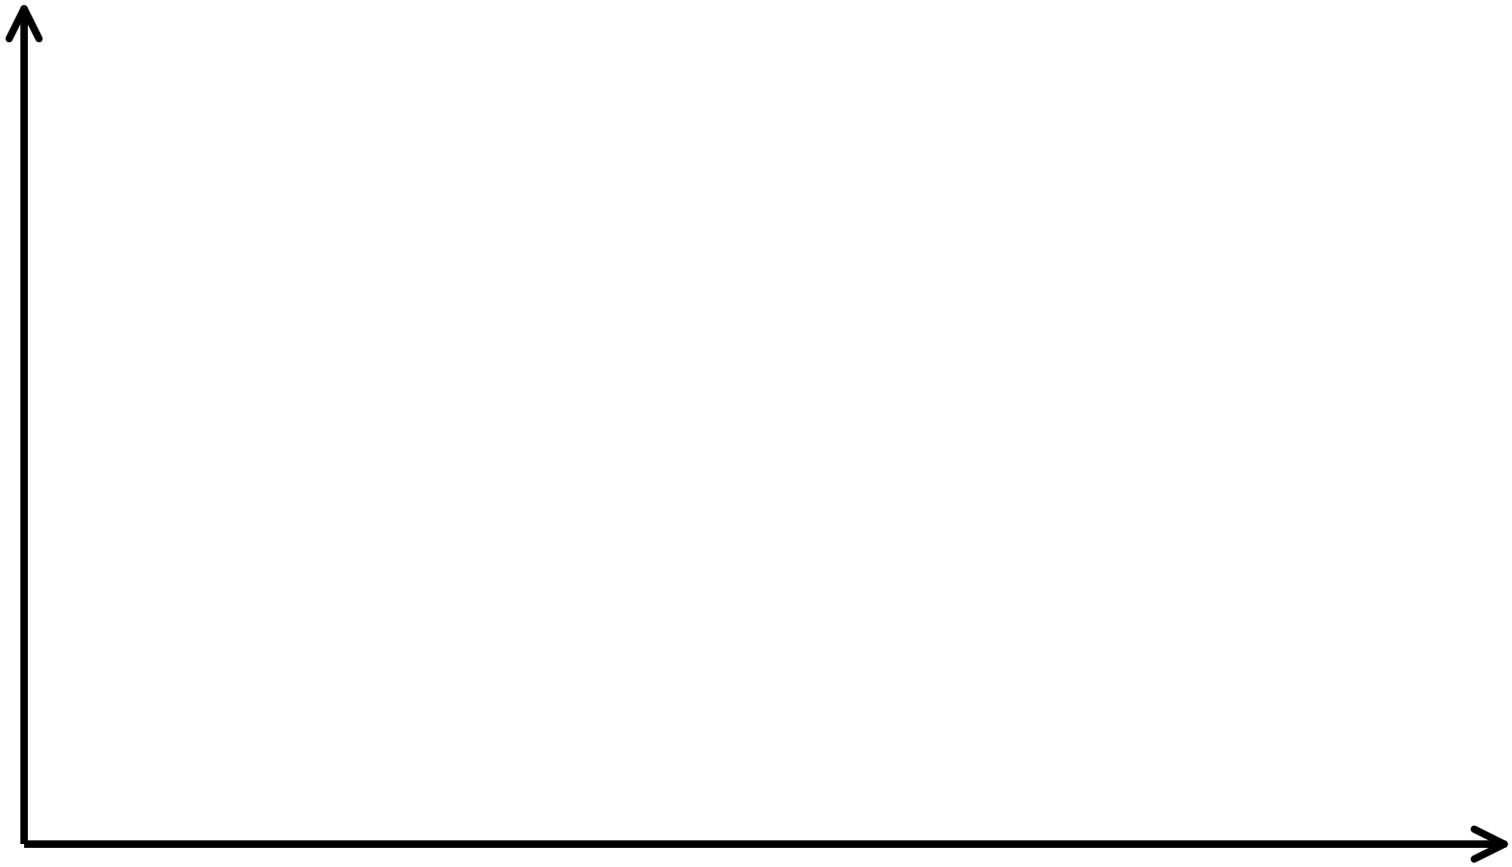(c) Construct a side-by-side column graph of the sample results.

(d) Hence or otherwise compare and contrast the distributions.

**Question Six: [1, 2, 2, 1 = 6 marks] CA**

A random sample of 15 items from a normal distribution with a mean of 100 and a standard deviation of 12 are given below.

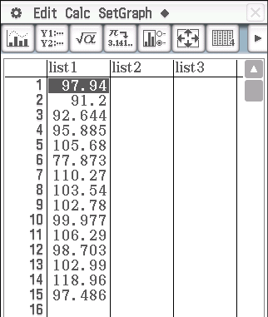

(a) What proportion of items do you expect to lie within two standard deviations of the mean?

(b) Calculate the mean and standard deviation for this sample.

(c) What proportion of items in this sample lie within two standard deviations of the mean?

(d) If a random sample of 100 items had been created instead, what would you notice about the variability of the mean and standard deviation between the larger sample and the one given above?

**SOLUTIONS**

**Calculator Assumed**

**Random Sampling and Distributions**

Time: 45 minutes

Total Marks: 45

Your Score: / 45



**Question One: [2, 2, 3, 3 = 10 marks] CA**

For each of the following samples, determine whether the sample is bias and if so, state the reason(s) for the bias.

(a) During an episode of The Biggest Loser, a weight loss show, the viewing audience were asked to SMS in either Yes or No to the following question: “Do you eat fastfood more than once a week?”

Non response bias

(b) A class of Year 8 students are asked to complete a compulsory survey for the following question: “Should the School reduce the lunch hour to 30 minutes?” Selection bias

(c) A random sample of residents in a particular suburb were asked: “Do you prefer Hungry Jacks’ over other competitors?”

Design bias and Selection bias

(d) Over the course of a Saturday, shoppers in the city central shopping mall were approached and asked: “Do you think the US response to the September 11 attacks was appropriate?”

Selection and Recall/Reporting bias

**Question Two: [5 marks] CA**

At the office of Dunder/Mifflin, a company selling stationery supplies, there are the following number of employees:

1 Manager

7 Sales Representatives

2 Office Assistants

3 Accountants

13 Warehouse employees

The Manager, Michael Scott, wants the Human Resources representative to survey 5 staff on the success of their Positivity Day.

If the Human Resources representative does this proportionally, how many of each staff group should he select?



3 warehouse employees



1 sales representative



1 accountant

**Question Three: [3, 3 = 6 marks] CA**

Two digit random numbers have been created using an excel spreadsheet. A screen shot of these numbers is shown below.



(a) Starting in column F and row 5, collect a systematic sample of size 8 of numbers between 74 and 150 inclusive.

 114 127 78 108 89 75 121 124



(b) Landline phone numbers in Australia begin with an area code, followed by a 9 and then followed by 7 digits. Starting in column K and row 15, collect a sample of 10 phone numbers (ignoring the area codes).

3450363 0766741 3361915 8645243 2050102

 1252439 1056974 5916285 6774581 0248229

**Question Four: [2, 2, 2, 3 = 9 marks] CA**

At a particular bus stop during morning peak hour, the waiting time for the next bus is between 0 seconds and 300 seconds.

(a) Define the random variable that would model this situation.

 

(b) Determine the mean and standard deviation for this distribution.

 

During peak hour on a Monday morning, random samples of waiting times were observed for this bus stop. These times are shown below.

(c) Calculate the mean and standard deviation for the above sample.

 

(d) By grouping the data appropriately, draw a graph of the sample distribution on the axes below.

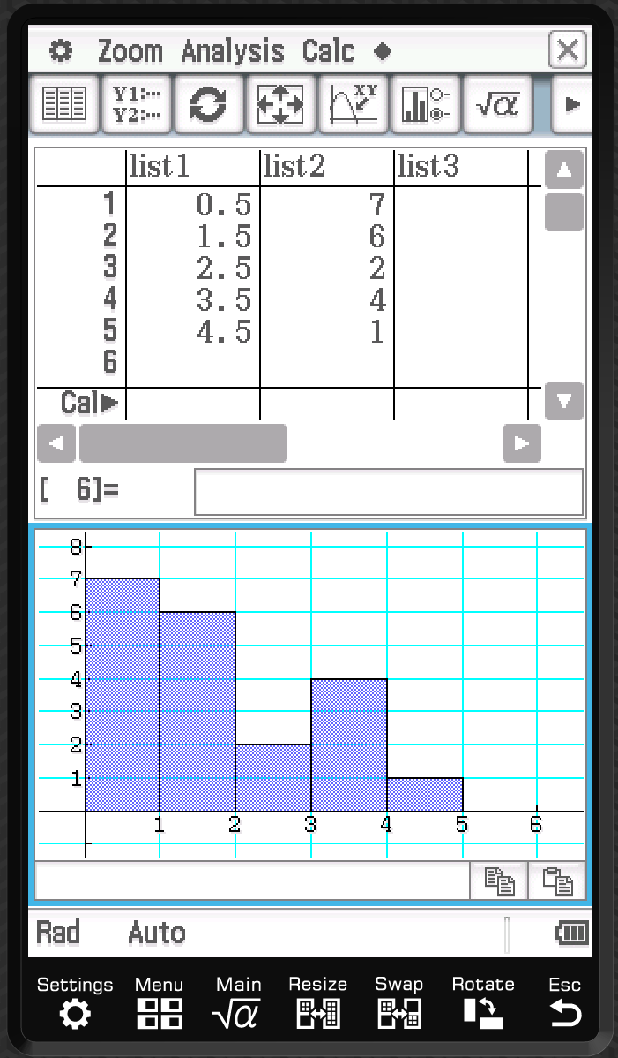

**Question Five: [2, 2, 3, 2 = 9 marks] CA**

A Bernoulli trial is such that the probability of success is 0.4.

Two random samples of 12 trials is given below:



(a) Calculate the mean and standard deviation of the first sample, given in list 1.

 

(b) Calculate the mean and standard deviation of the second sample, given in list 2.

 

(c) Construct a side-by-side column graph of the sample results.

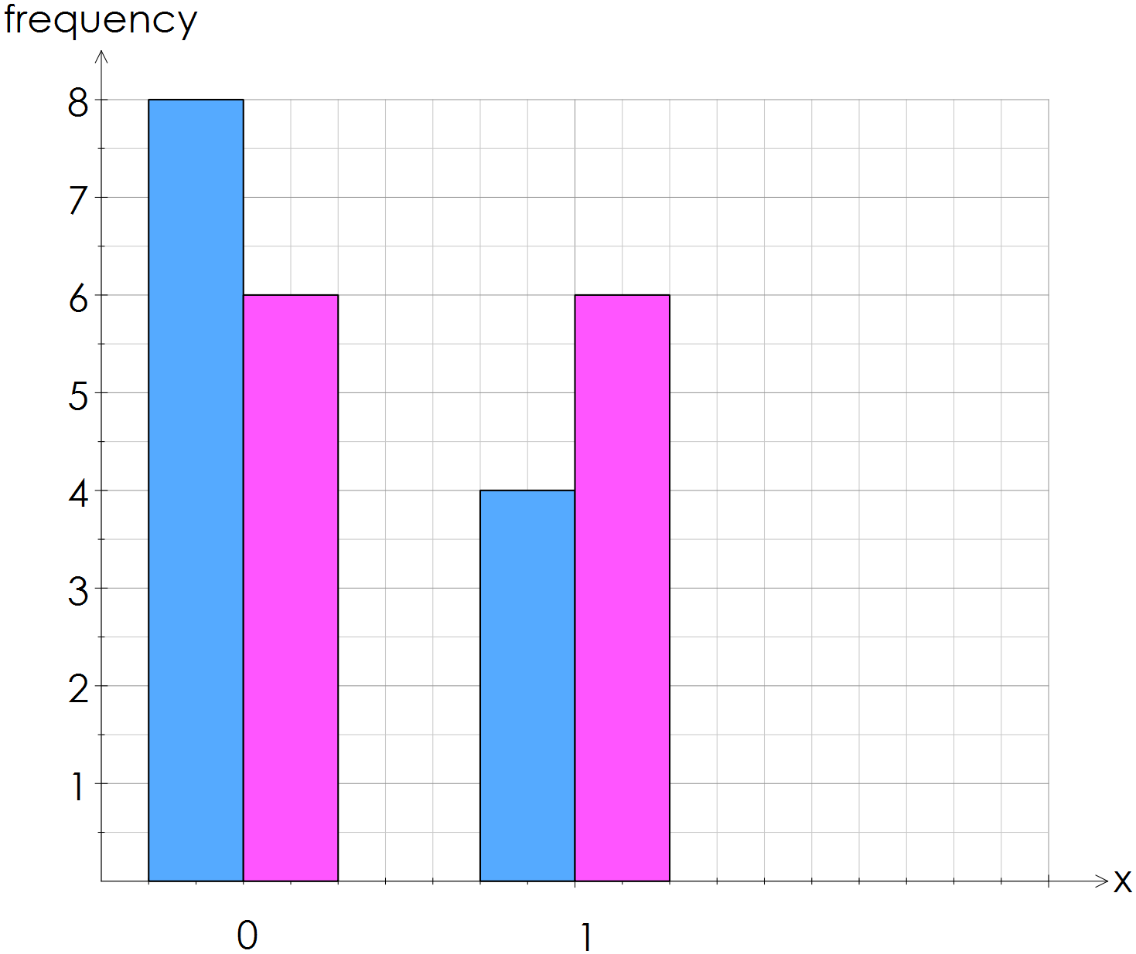







(d) Hence or otherwise compare and contrast the distributions.

The second sample has a perfectly symmetrical distribution while the first sample is slightly positively skewed.

**Question Six: [1, 2, 2, 1 = 6 marks] CA**

A random sample of 15 items from a normal distribution with a mean of 100 and a standard deviation of 12 are given below.



(a) What proportion of items do you expect to lie within two standard deviations of the mean?

0.95

(b) Calculate the mean and standard deviation for this sample.

 

(c) What proportion of items in this sample lie within two standard deviations of the mean?

 

(d) If a random sample of 100 items had been created instead, what would you notice about the variability of the mean and standard deviation between the larger sample and the one given above?

The mean and standard deviation would be much closer to the mean and standard deviation of the distribution.